CSCI222 Assignment 1 Report

|  |  |  |  |
| --- | --- | --- | --- |
| **Team Number : <C1>** | | | |
|  | **Student Number** | **Name** | **Email Address** |
| 1 |  | (Team Leader) | Tel :    Email : |
| 2 |  |  |  |
| 3 |  |  |  |
| 4 |  |  |  |
| 5 |  |  |  |
| 6 |  |  |  |
|  |  |  |  |

Table of Contents

Contents

# Project Overview

In this assignment, the primary focus is targeted at the ability to provide a warehouse inventory management system for the user. This system is crucial as it will strive to streamline processes and optimise productivity and day-to-day operations. Staff members are able to make use of the provided summary data to conduct critical decision-making operations that will directly impact the organization.

It is therefore paramount for the organization to have an effective system in place with an effective security coverage, pinpoint accuracy for data summary and a robust system to maintain the highest uptime.

Examples of relevant information includes:

1. **"Vision"**

We strive to create a program which is closely suited to user requirement and have as little constraint as possible

1. **Initial Use-Case Model**

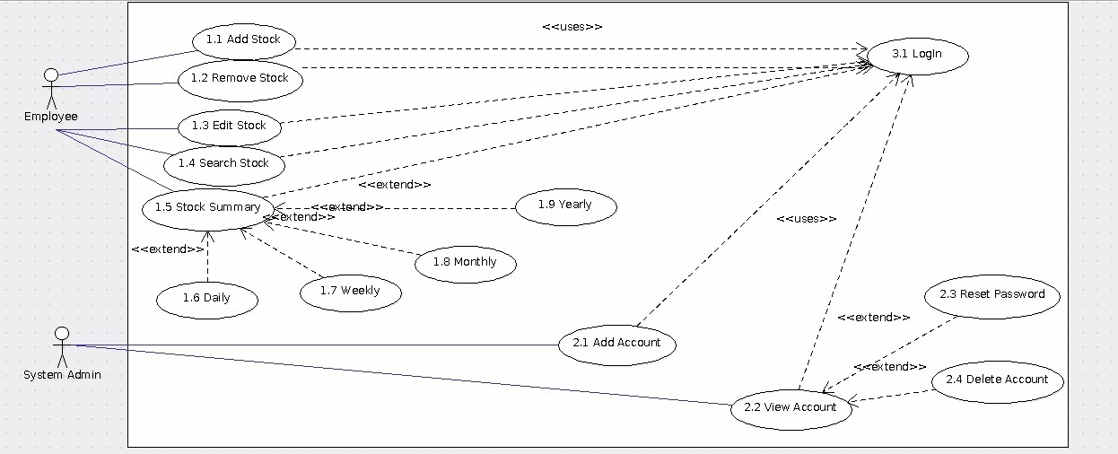

As shown in the diagram above, there are mainly two actors; Employee and System Admin who will be required to using login to use any of the usecase.

For the Employee they can do the following, Add Stock, Remove Stock, Edit Stock, Search Stock and Stock Summary. Which Stock Summary is then extend to Daily, Weekly, Monthly and Yearly.

For the System Admin they can do the following, Add Account and View Account. Which View Account is extend to Reset Password and Delete Account.

1. **Project Plan**

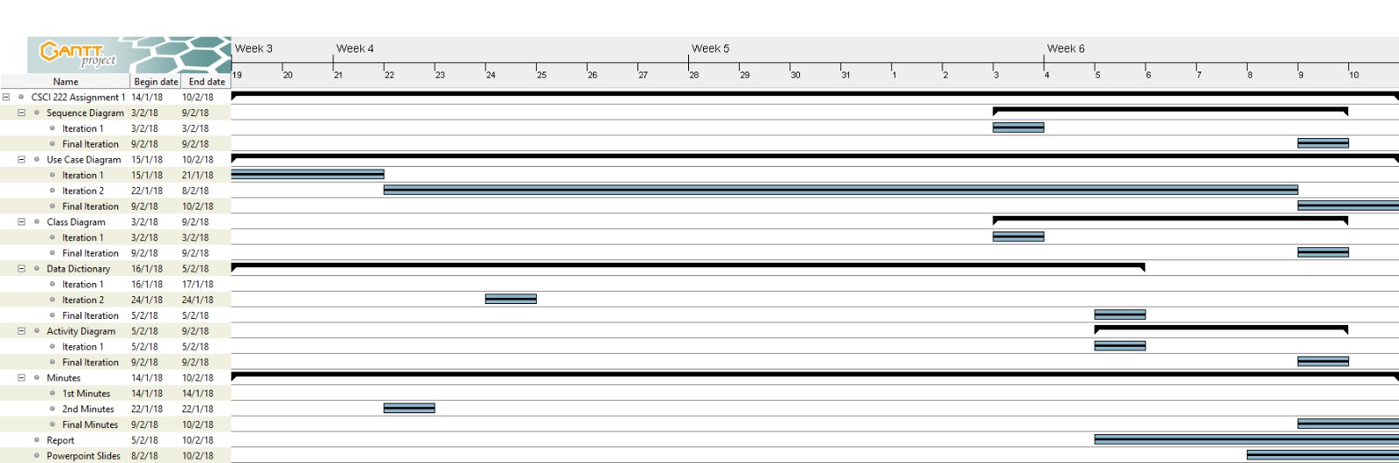

Roles and Responsibility

|  |  |  |  |
| --- | --- | --- | --- |
| Team Number : <put your assigned team number here> | | | |
|  | **Student Name** | **Role** | **Artefacts** |
| 1 |  | < E.g. Manager, Designer, Systems Integration, Tester, Documenter, etc > | < E.g. Use Case Diagram, Report - Section 2, TestCase.h, TestCase.cpp, etc > |
| 2 | Randy Tung Keng Guan |  | Class Diagram, Activity Diagram & Report |
| 3 |  |  |  |
| 4 |  |  |  |
| 5 |  |  |  |
| 6 |  |  |  |

Risk Analysis and Counter Measures

Column **Impact Type** -What is the type of impact affected by the risk? E.g. Deadline/Budget/Successful Task Completion/etc.

Column **Risk Seriousness (%)** - how serious the risk affects the project

Column **Likelihood of Occurrence (%)**  - how likely is the risk to happen

Column **WBS (affected work/task)** - the work/task id(s) in WBS affected by the risk

Column **Risk Description** - what is nature of the risk

|  |  |  |  |  |  |
| --- | --- | --- | --- | --- | --- |
|  | **Impact Type** | **Risk Seriousness (%)** | **Likelihood of Occurrence (%)** | **WBS**  **(affected work / task )** | **Risk Description** |
| 1 | Security | 20% | 40% |  | Password guessing on user accounts after multiple unlocks |
| 2 | Deadline | 90% | 10% |  | Unable to complete project on time due to time constraint |

Column **Risk Description** - what is nature of the risk

Column **Proposed**  **Mgmt Plan** - what is your plan(s) to reduce / eliminate the risk

Column **(Possible) Reduction in Risk Seriousness (%)** -

|  |  |  |  |
| --- | --- | --- | --- |
|  | **Risk Description** | **Proposed Mgmt Plan** | **(Possible) Reduction in Risk Seriousness (%)** |
| 1 | Password guessing on user accounts after multiple unlocks | Plan 1 : Change password every 90 days | -10% |
| Plan 2 : Accounts will lock after 3 attempt | -10% |
| 2 | Unable to complete project on time due to time constraint | Plan : will adhere closely to the project gantt chart | -40% |

Design Artefacts - Use Cases (Iteration 1)

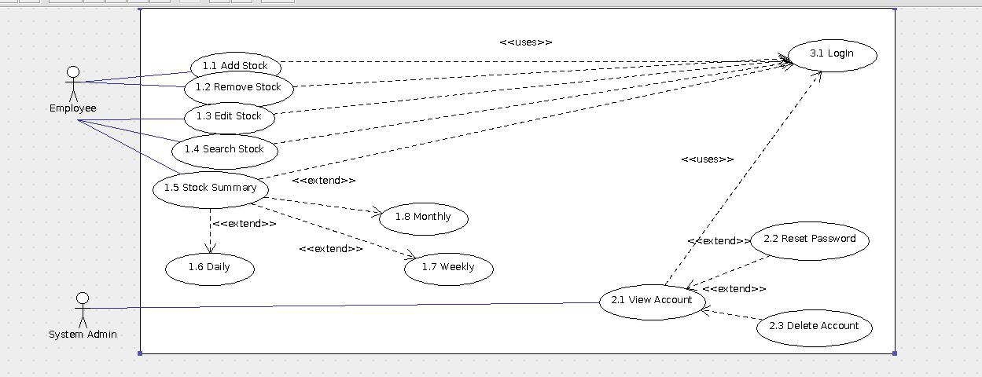

Design Artefacts - Use Cases (Iteration 2)



Design Artefacts - Activity Workflows (Iteration 1)

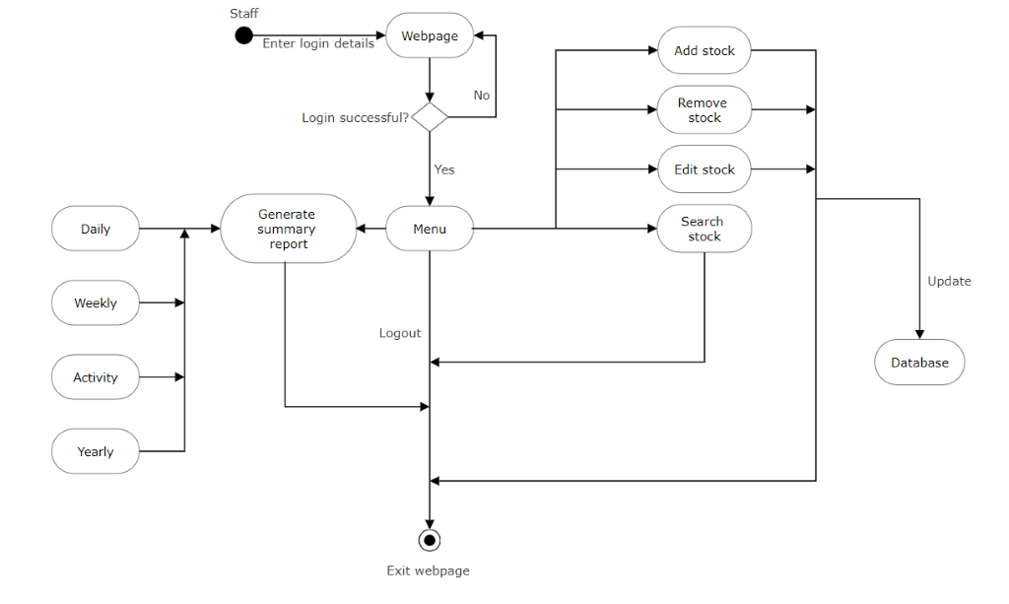

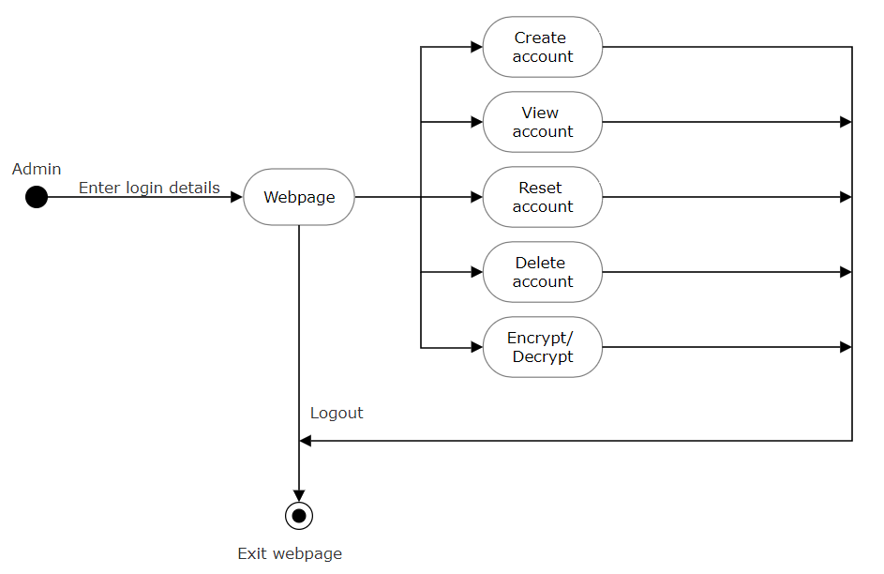

Design Artefacts - Activity Workflows (Iteration 2)

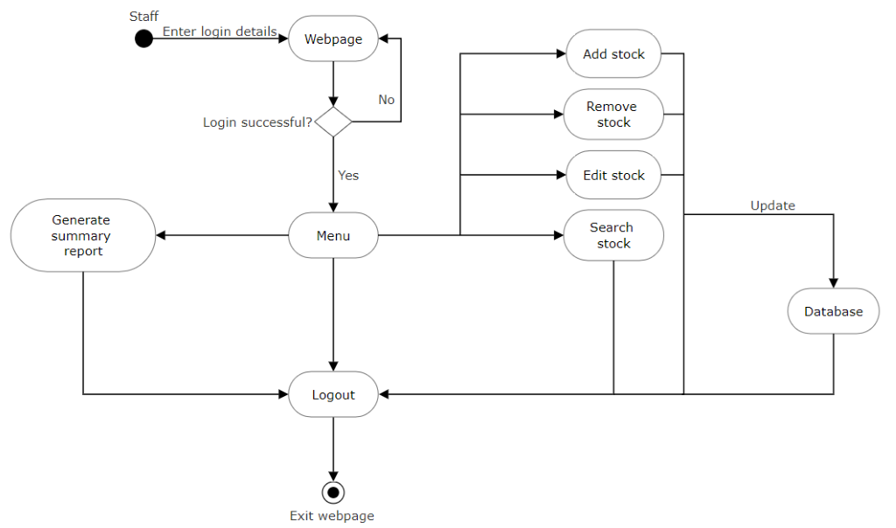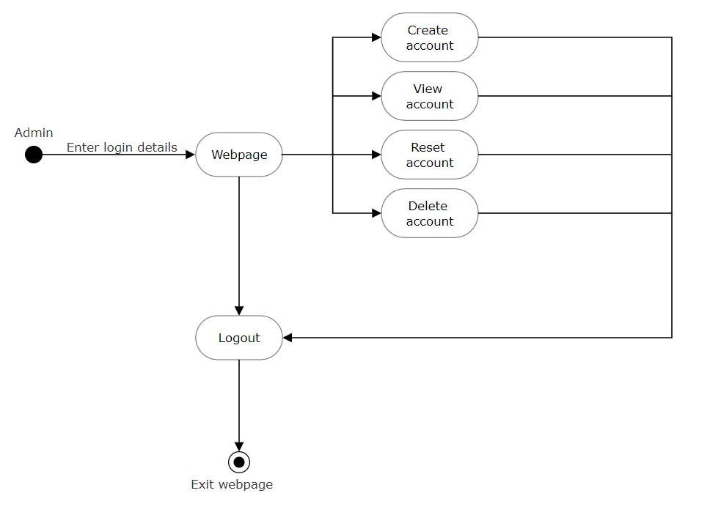

Design Artefacts - Component Diagrams (Iteration 1)

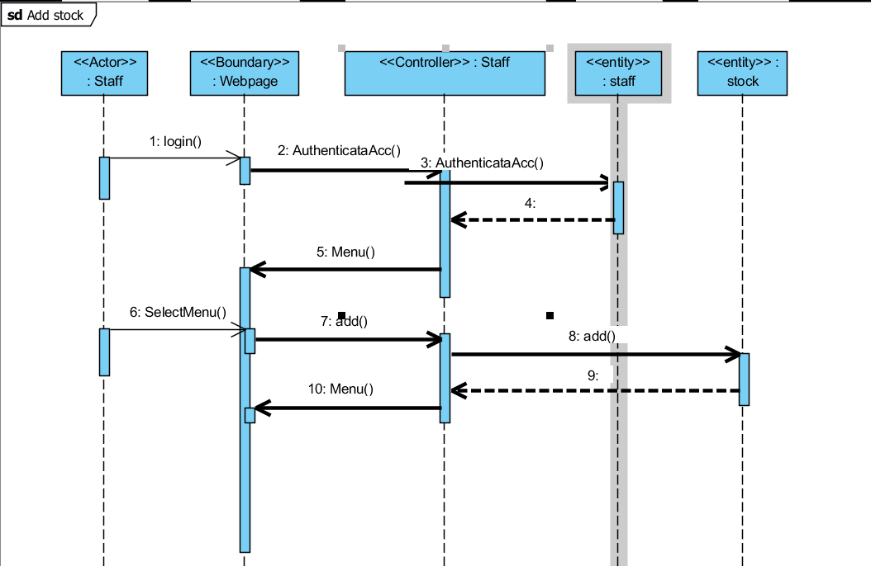

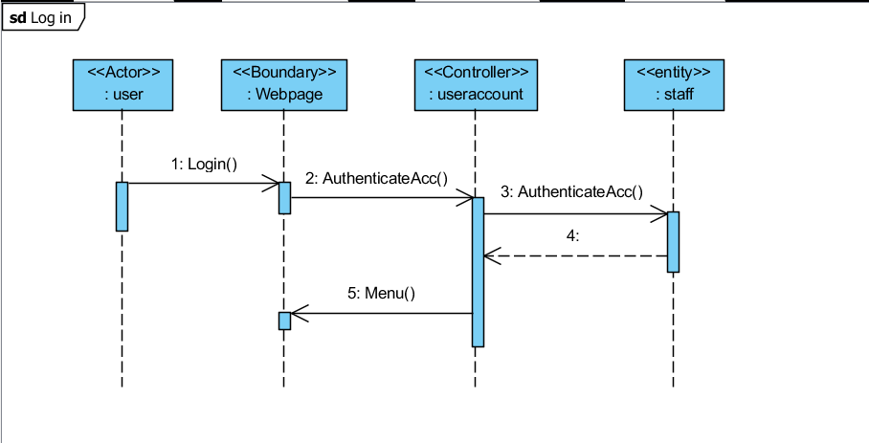

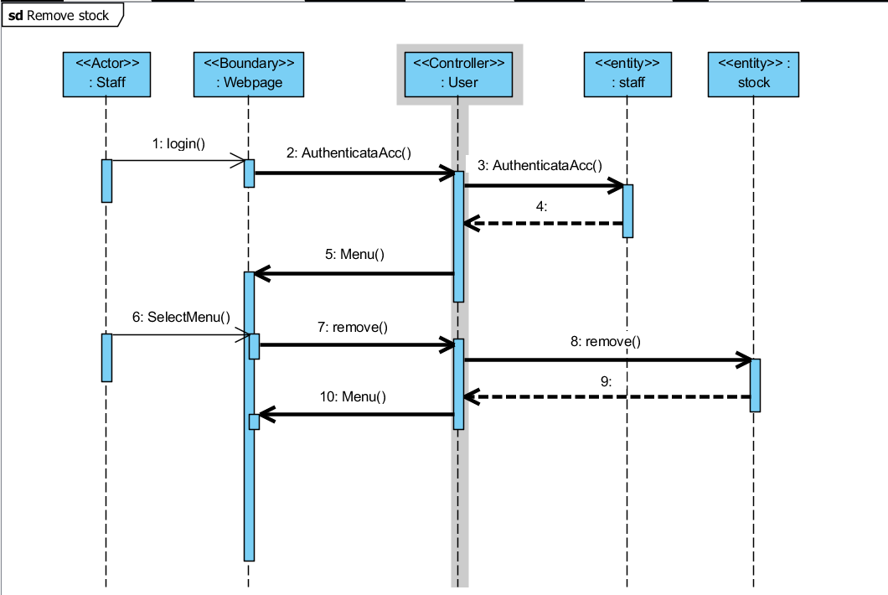

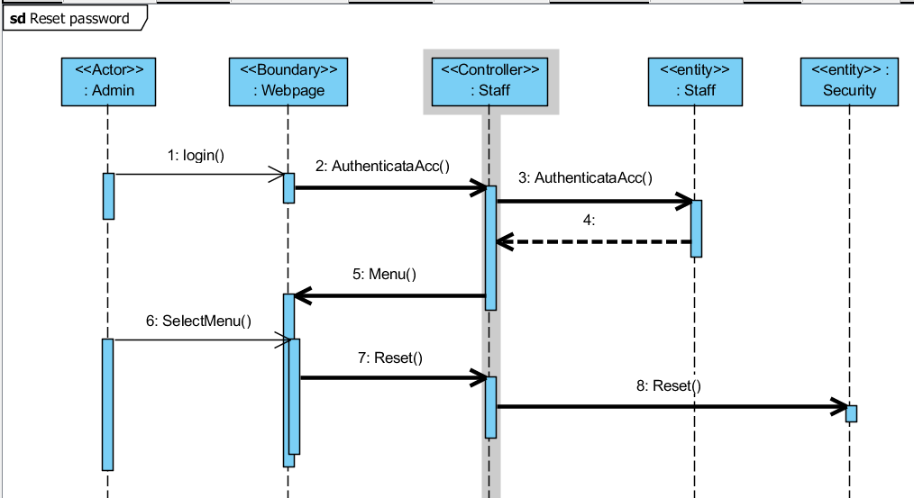

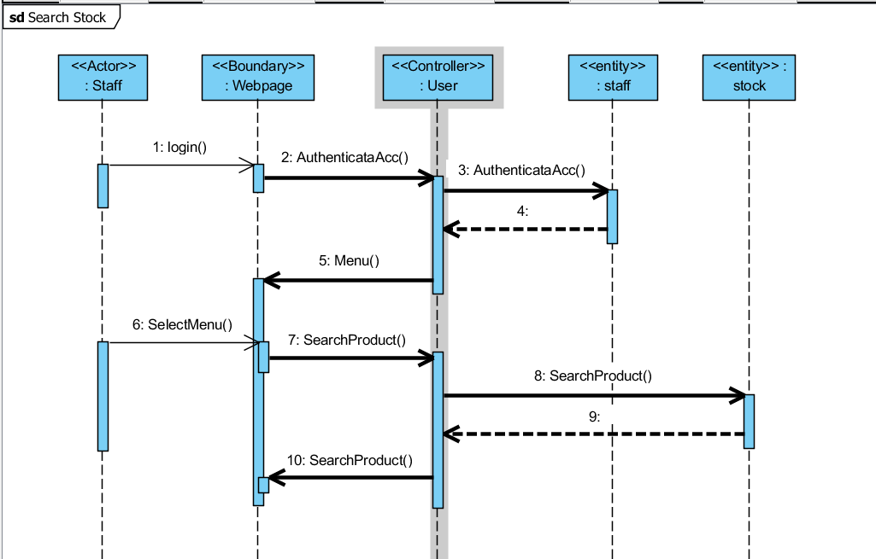

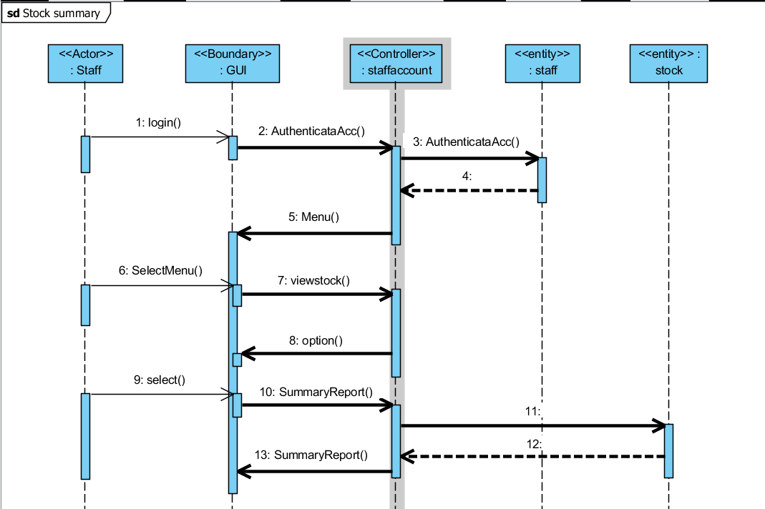

Design Artefacts - Component Diagrams (Iteration 2)

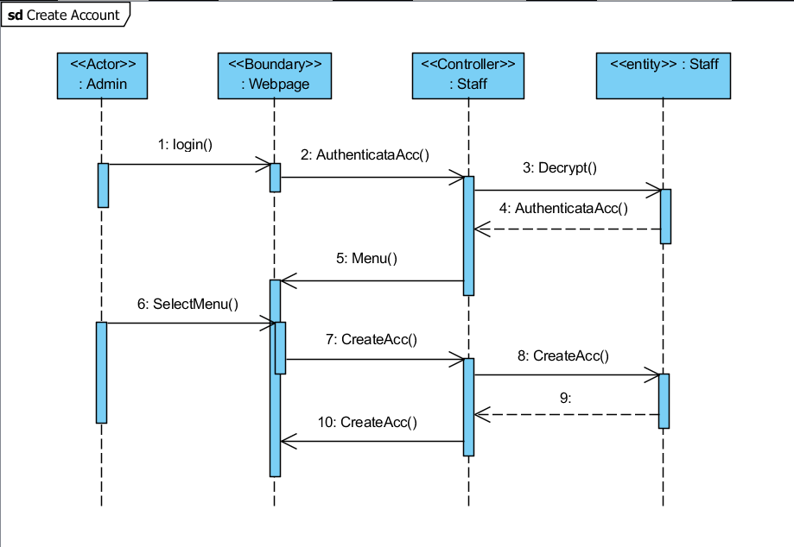

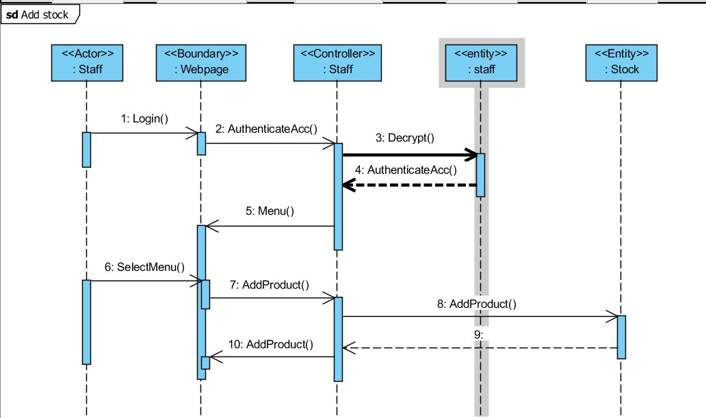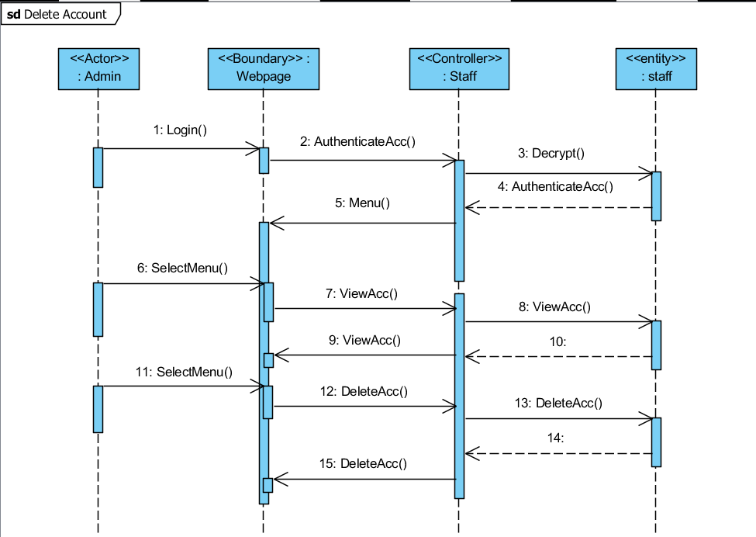

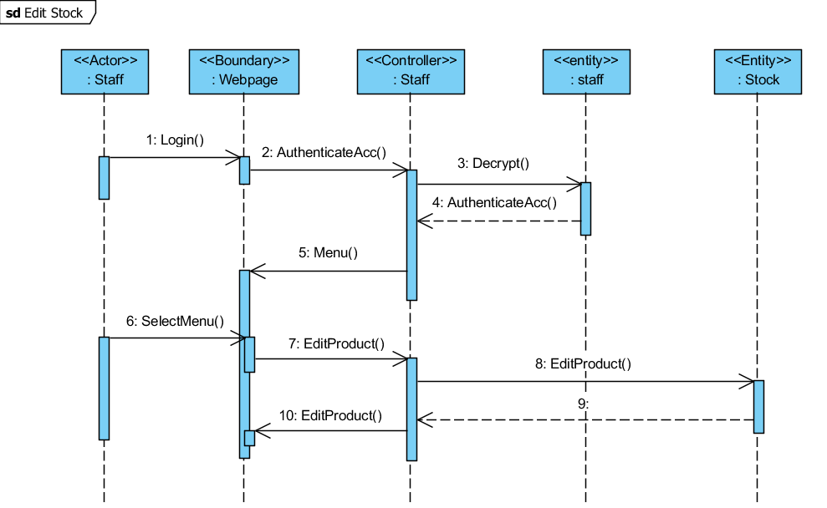

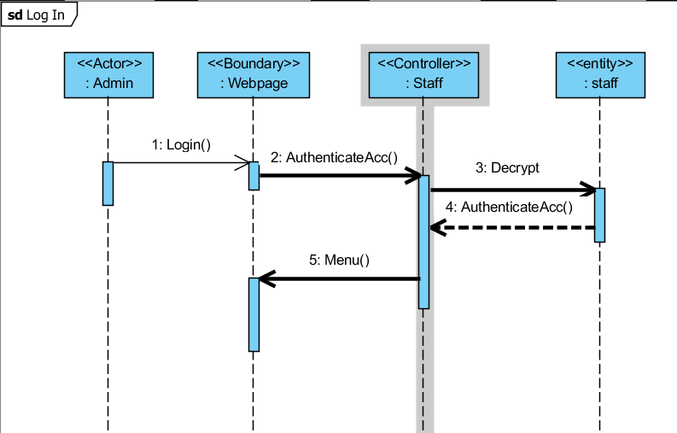

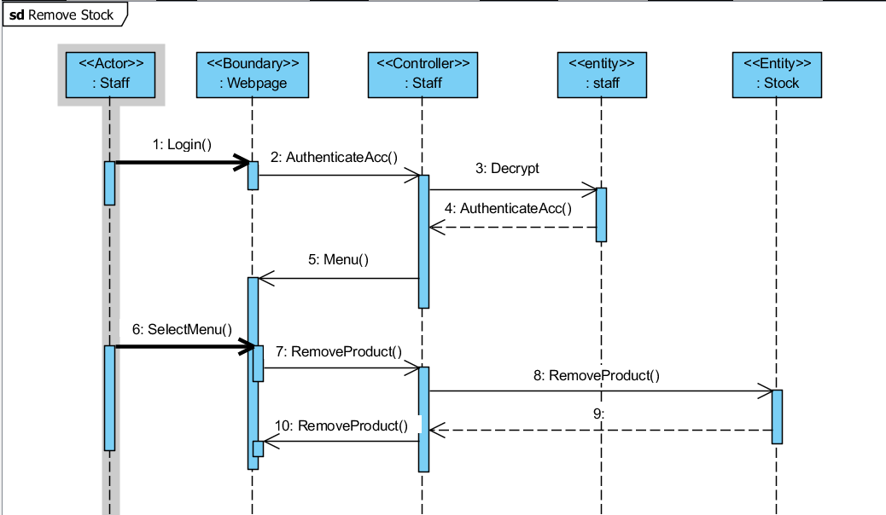

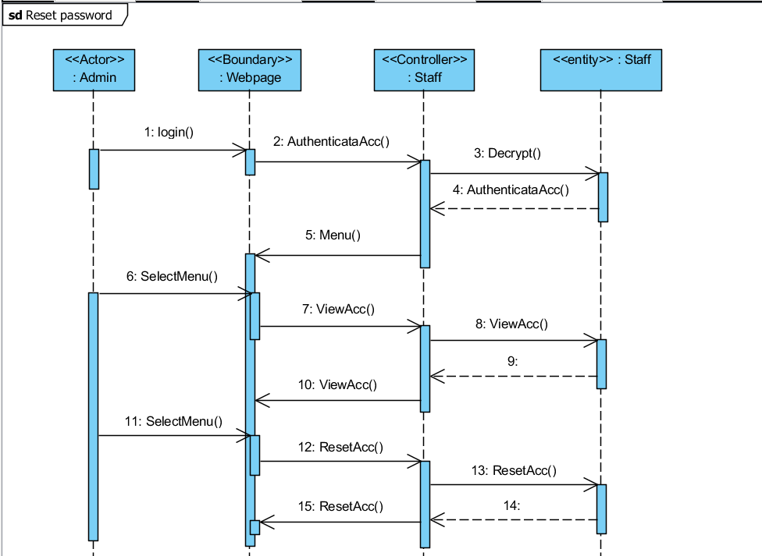

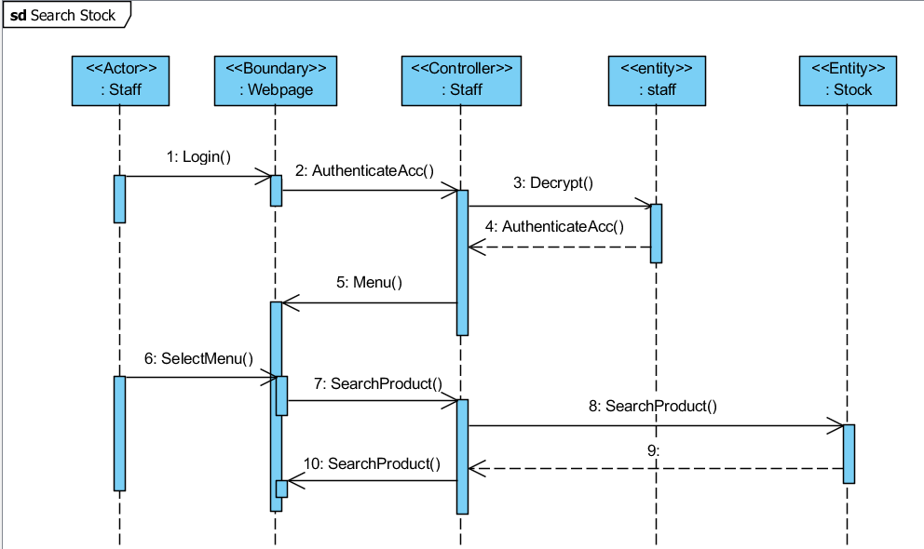

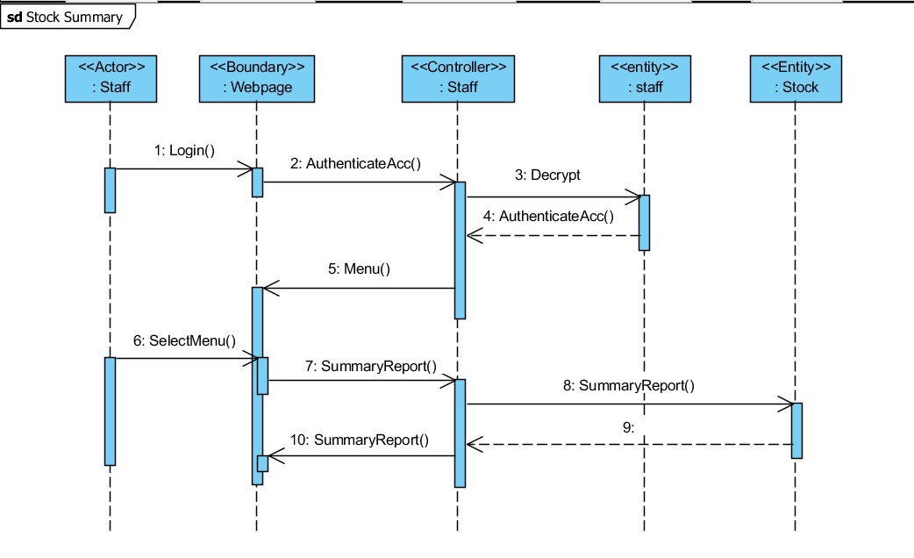

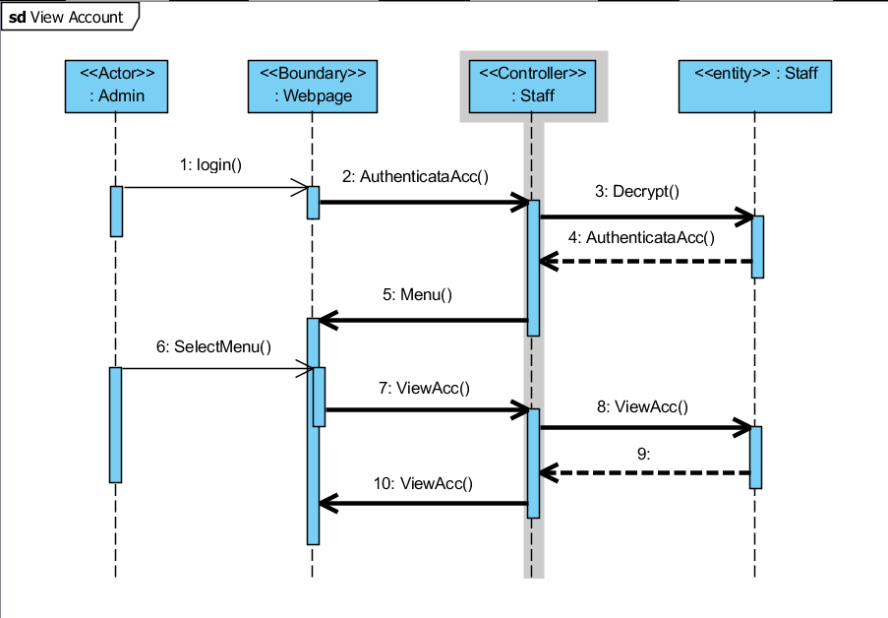

Design Artefacts - Class Diagrams (Iteration 1)

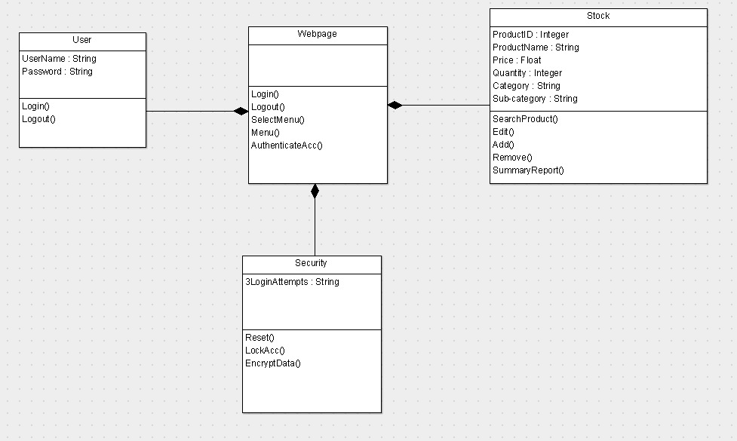

Design Artefacts - Class Diagrams (Iteration 2)

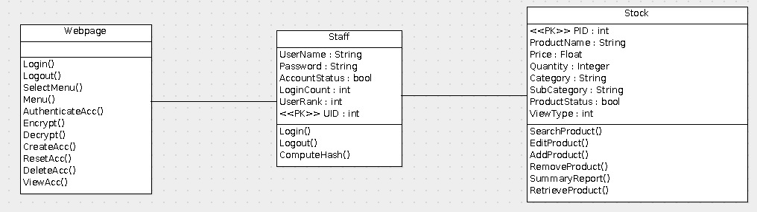

Design Artefacts - <Any other diagrams> (Iteration 1)

Depending on your system's software architecture, there may be many other diagrams (e.g. ER-Model, State / Interaction / Activity Diagrams, etc) which are applicable and should be reflected in your Design Artefacts section of your report.

Please "reuse the same structure" you see for the earlier sections on Use Case / Class / Component diagrams, together with 2 iterations version, for your diagrams in this section.

You may use any diagramming tool to develop your diagrams.

Iteration 1 is based on your team's "**INITIAL**"understanding of the system.

Note 1 : Your diagram should be developed using standard UML symbols and notations that is relevant for that particular type of diagram!

Note 2 : this section can span as many pages as necessary

Note 3 : If you are pasting screen-shots (from your adopted diagramming tool) into this sub- section, please ensure all the wordings / text are clearly visible

Design Artefacts - <Any other diagrams> (Iteration 2)

Depending on your system's software architecture, there may be many other diagrams (e.g. ER-Model, State / Interaction / Activity Diagrams, etc) which are applicable and should be reflected in your Design Artefacts section of your report.

Please "reuse the same structure" you see for the earlier sections on Use Case / Class / Component diagrams, together with 2 iterations version, for your diagrams in this section.

You may use any diagramming tool to develop your diagrams.

Iteration 2 is based on your team's "**LATEST**"understanding of the system.

In general, the diagrams in ***later*** iterations should be more refined, more evolved, capture more details than diagrams developed in ***earlier*** iterations

Note 1 : Your diagram should be developed using standard UML symbols and notations that is relevant for that particular type of diagram!

Note 2 : this section can span as many pages as necessary

Note 3 : If you are pasting screen-shots (from your adopted diagramming tool) into this sub- section, please ensure all the wordings / text are clearly visible

Appendix A - Formal Meeting Records

Inception Phase - Iteration 1

* Copy and Paste your formal meeting minutes for Inception Phase, iteration 1 here.
* You can refer to Assn 1 Qn Paper, Appendix B, bullet point 4 for a summary of contents to be included.
* Note: this section can span as many pages as necessary

Inception Phase - Iteration 2 (Optional)

* Copy and Paste your formal meeting minutes for Inception Phase, iteration 2 here.
* You can refer to Assn 1 Qn Paper, Appendix B, bullet point 4 for a summary of contents to be included.
* Note: this section can span as many pages as necessary

Elaboration Phase - Iteration 1

* Copy and Paste your formal meeting minutes for Elaboration Phase, iteration 1 here.
* You can refer to Assn 1 Qn Paper, Appendix B, bullet point 4 for a summary of contents to be included.
* Note: this section can span as many pages as necessary

Elaboration Phase - Iteration 2

* Copy and Paste your formal meeting minutes for Elaboration Phase, iteration 2 here.
* You can refer to Assn 1 Qn Paper, Appendix B, bullet point 4 for a summary of contents to be included.
* Note: this section can span as many pages as necessary

Elaboration Phase - Iteration 3 (Optional)

* Copy and Paste your formal meeting minutes for Elaboration Phase, iteration 3 here.
* You can refer to Assn 1 Qn Paper, Appendix B, bullet point 4 for a summary of contents to be included.
* Note: this section can span as many pages as necessary

Appendix B - Individual Work Diaries

Team Member 1 : Randy Tung Keng Guan

**Daily Work Diary (3rd Feb 2018)**

|  |  |
| --- | --- |
| **Task – Class Diagram (Iteration 1)** | |
| 1200-1205 | Informed Benedict to startup his desktop and VOIP application to begin assignment |
| 1205-1245 | Reviewed the assignment document to identify key classes for the skeleton class diagram |
| 1245-1300 | Drew skeleton class diagram and concluded iteration 1 |
| 1300-1400 | Brainstormed with Benedict on all possible activities the actor can have |
| 1400-1430 | Drew skeleton activity diagram and concluded iteration 1 |
| *Hours worked = 2.5 hours* | |
| ***Total Hours worked = 2.5 hours*** | |

**Daily Work Diary (9th Feb 2018)**

|  |  |
| --- | --- |
| **Task – Class Diagram (Final Iteration)** | |
| 1200-1205 | Met up with entire group to discuss on comments and questions on iteration 1 diagram |
| 1205-1330 | Reviewed the assignment document to identify key classes for the final class diagram |
| 1330-1400 | Drew final class diagram |
| **Task – Activity Diagram (Final Iteration)** | |
| 1400-1430 | Met up with entire group to discuss on comments and questions on iteration 1 diagram |
| 1430-1500 | Edited activity diagram to reflect recent comments and changes |
| *Hours worked = 3 hours* | |
| ***Total Hours worked = 3 hours*** | |

Team Member 2 : Eugene Tan

**Daily Work Diary (15 Jan 2018 – 21 Jan 2018)**

|  |  |
| --- | --- |
| Tasking – Sequence Diagram |  |
| 18 Jan 2018 1300-1600 | Started on the first iteration of sequence diagram based on both use case and class  diagram |
| Sub-Task – Sequence Diagram (Cont’d) |  |
| 18 Jan 2018 1800-1930 | Continue doing sequence diagram and add in methods based on class diagram |
| ***Total Hours worked = 4.5 hours*** |  |

**Daily Work Diary (22 Jan 2018 – 8 Feb 2018)**

|  |  |
| --- | --- |
| Tasking – Edit sequence diagram based on new iteration of class and use case diagram |  |
| 26 Jan 2018 1400-1600 | Started doing second iteration of sequence diagram after use case and class diagram had been edited based on meeting comments. |
| Tasking – Doing SRS pointer two |  |
| 28 Jan 2018 1400-1800 | Started doing SRS for pointer two |
| Sub-Task Detailed for SRS pointer two |  |
| 28 Jan 2018 1400-1500 | Research online to see example of SRS and have a better understanding what SRS  should include |
| ***Total Hours worked = 6 Hours*** |  |

**Daily Work Diary (9 Feb 2018 – 11 Feb 2018)**

|  |  |
| --- | --- |
| Tasking – Final changes for sequence diagram |  |
| 09 Feb 2018 2100-2130 | During the meeting, there were final changes made to use case diagram, and had to draw a new sequence diagram for “add user”. |
| Tasking – Help compiling SRS |  |
| 10 Feb 2018 1200-1230 | Compile SRS after Darwin and Joshua send me their part for SRS |
| *Tasking – Added sequence diagram into report* |  |
| 10 Feb 2018 1400-1430 | Added both iteration of sequence diagram into report and send to team members to add into their report |
| ***Total Hours worked =1.5 Hours*** |  |

Team Member 3 : Darwin

**Daily Work Diary (17th Jan 2018)**

|  |  |  |
| --- | --- | --- |
| Task – Data Diagram (Iteration 1) |  |  |
| 1200-1300 | Edit data dictionary to better suit our system scenario |  |
| *Task –* System Requirements Specification |  |  |
| 1330-1430 | Completed segment 1 of SRS (purpose and document convention) |  |
| *Hours worked = 2* |  |  |
| ***Total Hours worked = 2*** |  |  |

**Daily Work Diary (24th Jan 2018)**

|  |  |  |
| --- | --- | --- |
| Task – Data Diagram (Iteration 2) |  |  |
| 1200-1330 | Improved data dictionary base on class diagram |  |
| *Task –* Risk Analysis and Counter Measures (part 1) |  |  |
| 1400-1500 | Start on risk analysis and counter measures |  |
| *Hours worked = 2.5* |  |  |
| ***Total Hours worked = 2.5*** |  |  |

**Daily Work Diary (28th Jan 2018)**

|  |  |  |
| --- | --- | --- |
| Task – System Requirements Specification |  |  |
| 1200-1400 | Completed part 1 of SRS (Introduction) |  |
| *Hours worked = 2* |  |  |
| ***Total Hours worked = 2*** |  |  |

**Daily Work Diary (5th Feb 2018)**

|  |  |  |
| --- | --- | --- |
| Task – System Requirements Specification |  |  |
| 1200-1400 | Completed risk analysis and counter measures |  |
| Task - PowerPoint |  |  |
| 1430-1630 | Start on group’s powerpoint |  |
| *Hours worked = 4* |  |  |
| ***Total Hours worked = 4*** |  |  |

**Daily Work Diary (5th Feb 2018)**

|  |  |  |
| --- | --- | --- |
| Task – Data Diagram (Finalised) |  |  |
| 1200-1330 | Discussed and came up with a final data dictionary based on the finalized class diagram |  |
| Task - PowerPoint |  |  |
| 1330-1500 | Integrated everyone’s finished diagrams into the powerpoint. |  |
| *Hours worked = 3* |  |  |
| ***Total Hours worked = 3*** |  |  |

Team Member 4 : Benedict Say

**Daily Work Diary (3rd Feb 2018)**

|  |  |
| --- | --- |
| **Task – Class Diagram (Iteration 1)** |  |
| 1200-1205 | Startup up my desktop and VOIP application to begin assignment with Randy |
| 1205-1245 | Went through assignment document to identify key classes for the skeleton class diagram |
| 1245-1300 | Drew skeleton class diagram and concluded iteration 1 |
| *Hours worked = 1 hour* |  |
| **Task – Activity Diagram (Iteration 1)** |  |
| 1300-1400 | Brainstormed with Randy on all possible actors and activities they can have |
| 1400-1430 | Drew skeleton activity diagram and concluded iteration 1 |
| *Hours worked = 1.5 hours* |  |
| ***Total Hours worked = 2.5 hours*** |  |

**Daily Work Diary (9th Feb 2018)**

|  |  |
| --- | --- |
| **Task – Class Diagram (Final Iteration)** |  |
| 1200-1205 | Met up with the group to discuss on comments and their views about final iteration diagram |
| 1205-1330 | Reviewed the assignment document to identify key classes for the final class diagram |
| 1330-1400 | Drew final class diagram |
| *Hours worked = 2 hours* |  |
| **Task – Activity Diagram (Final Iteration)** |  |
| 1400-1430 | Met up with the group to discuss on comments and their views about final iteration diagram |
| 1430-1500 | Edited activity diagram to implement recent comments and changes |
| *Hours worked = 1 hour* |  |
| ***Total Hours worked = 3 hours*** |  |

Team Member 5 : Joshua Tan

**Daily Work Diary (16th Jan 2018)**

|  |  |
| --- | --- |
| Task - Data Table (1st Iteration) |  |
| 2000-2030 | Picked up previous Data Table format |
| Task - Minutes for 150118 Meeting |  |
| 2000-2045 | Formatting of minutes document |
| 2045-2145 | Minutes for 150118 Meeting |
| *Hours worked = 1.5Hrs* |  |
| ***Total Hours worked = 1.5hrs*** |  |

**Daily Work Diary (20th Jan 2018)**

|  |  |
| --- | --- |
| Task - Minutes for 150118 Meeting |  |
| 1000-1045 | Final check on 150118 Minutes |
| 1045-1100 | Uploaded 150118 Minutes for team to review |
| Task – Software Requirements Specification Document |  |
| 2000-2100 | Worked on updating document into Word format |
| 2100-2200 | Worked on adding the documentation for the Login feature |
| *Hours worked = 3Hrs* |  |
| ***Total Hours worked = 1Hrs*** |  |

**Daily Work Diary (27th Jan 2018)**

|  |  |
| --- | --- |
| Task - Data Table (Final Iteration) |  |
| 1000-1005 | Checked Data Table with Class Diagram |
| 1005-1100 | Updated Data Table with Class Diagram |
| Task - SRS Features |  |
| 1105-1200 | Edited formatting for SRS Document |
| 1200-1300 | Added Login, Staff control panel and Admin control panel features to documentation |
| *Hours worked = 3Hrs* |  |
| ***Total Hours worked = 3Hrs*** |  |

Team Member 6 : Deston Guay

**Daily Work Diary (15 Jan 2018 – 21 Jan 2018)**

|  |  |
| --- | --- |
| Tasking - Usecase Diagram |  |
| 16 Jan 2018 1300-1400 | Started on the first iteration of usecase diagram by creating the usecase bubbles and verify that all the requirements are inside |
| Sub-Task – Usecase Diagram (Cont’d) |  |
| 17 Jan 2018 1300-1330 | Started on the use case diagram and did the includes and exclude lines in the use case. |
| Tasking – Upload to github first iteration |  |
| 21 Jan 2018 1600-1615 | Compile and upload to github to capture first iteration for usecase diagram |
| *Hours worked = 1.75 hours* |  |
| ***Total Hours worked = 1.75 hours*** |  |

**Daily Work Diary (22 Jan 2018 – 8 Feb 2018)**

|  |  |
| --- | --- |
| Tasking – Edit the Usecase Diagram based on feedback |  |
| 23 Jan 2018 1200-1230 | During the meeting, it was noted I have a few missing items in my use case diagram and edit it according, which is to add the missing items inside view stock. |
| Sub-Task Detailed use case diagram 1 |  |
| 26 Jan 2018 1330-1400 | Started on the first part of detailed usecase, by working on 4 use case |
| Sub-Task Detailed use case diagram 2 |  |
| 28 Jan 2018 2030-2100 | Started on the second part of detailed usecase, by working on the next 5 use case |
| Sub-Task Detailed use case diagram 3 |  |
| 30 Jan 2018 2100-2130 | Started on the third part of detailed usecase, by working on the final 5 use case |
| Tasking – Upload to github for first iteration |  |
| 7 Feb 2018 2000-2015 | Compile and upload to github to capture first iteration for detailed usecase |
| *Hours worked = 2.25 Hours* |  |
| ***Total Hours worked = 4 Hours*** |  |

**Daily Work Diary (9 Feb 2018 – 11 Feb 2018)**

|  |  |
| --- | --- |
| Tasking – Final iteration on use case diagram |  |
| 09 Feb 2018 2100-2130 | During the meeting, it was raised that admin can “add user”, which I can add into the usecase diagram |
| Tasking – Final iteration on detailed usecase |  |
| 10 Feb 2018 1200-1230 | During the meeting, it was raised that admin can “add user”, which I can add into the detailed usecase |
| *Hours worked = 1.0 Hours* |  |
| ***Total Hours worked = 5Hours*** |  |

Appendix C - Evidence of using VCS (Version Control Software)

Version Control Software used : Git – Github Desktop version

Screenshot #1 - Contents in the VCS's **Root Folder** containing all **Repository Project Files**

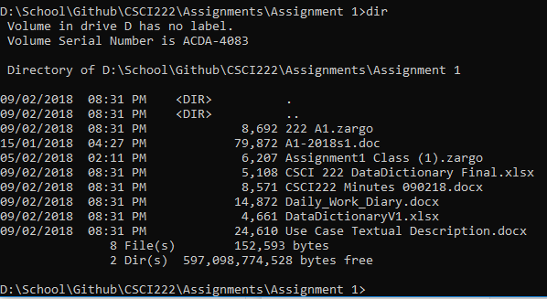

Figure C.1.1 – Screenshot of the repository in command prompt after entering Assignment 1 folder

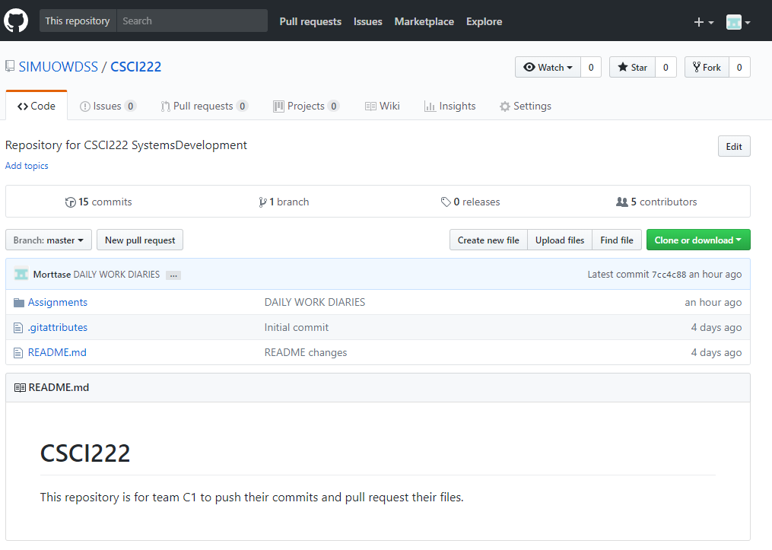

Figure C.1.2 – Screenshot of the root repository on github web.

Screenshot #2 - VCS's listing of all the **latest source files currently being managed**

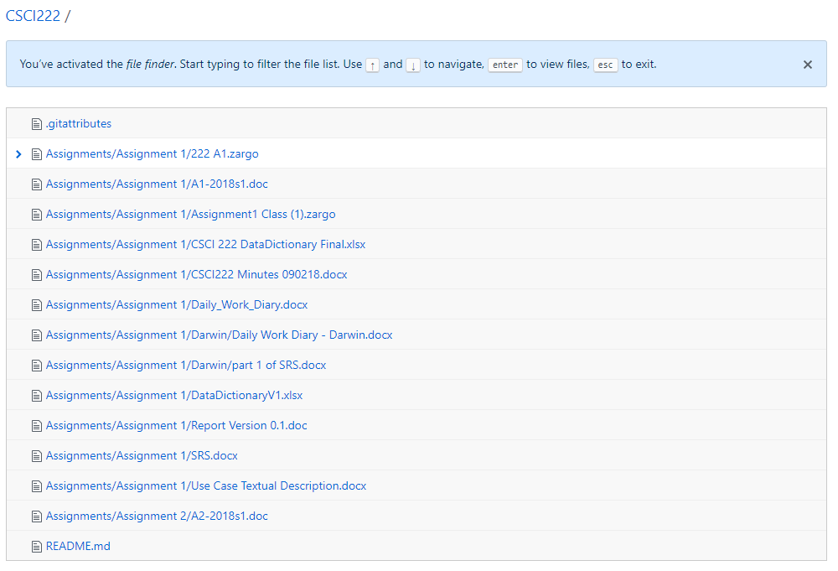

Figure C.2.1 – Screenshot showing all files that are currently managed in the repository.

Screenshot #3 - Example using VCS's to **check-out source files** (it may be necessary to do >1 screen capture, depending on the software used)

**One key feature of Github Desktop is that it allows the user flexibility to edit and make any changes before committing the file. Before committing, there would be 2 branches that separate the master file and the edited file. Once the pull request is created, the user is able to see the differences made between the 2 files. Once the user confirms that the changes are correct, he will then merge the request so that the file in the master branch would be updated to the latest version. Likewise, each action is recorded and tracked by a hash. The user would be able to backtrack to the previous version as Github saves them.**

Screenshot #4 - Example using VCS's to **check-in source files** (it may be necessary to do >1 screen capture, depending on the software used)

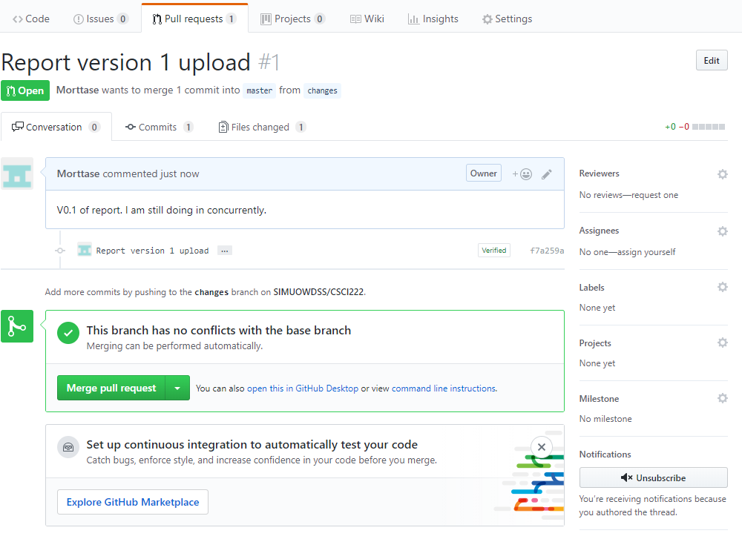

Figure C.4.1 – Screenshot showing the checking-in of source files and comparing it between 2 branches to ensure both data are equal.

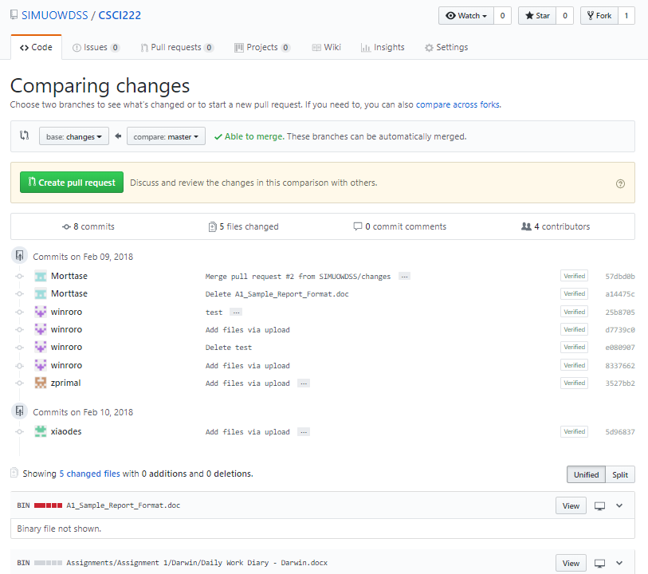

Figure C.4.2 – Screenshot showcases the changes between 2 branches. Allows the user to merge and create a pull request should there be no issues with the files.

Screenshot #5 - Example using VCS's to **display the change history / log** (it may be necessary to do >1 screen capture, depending on the software used)

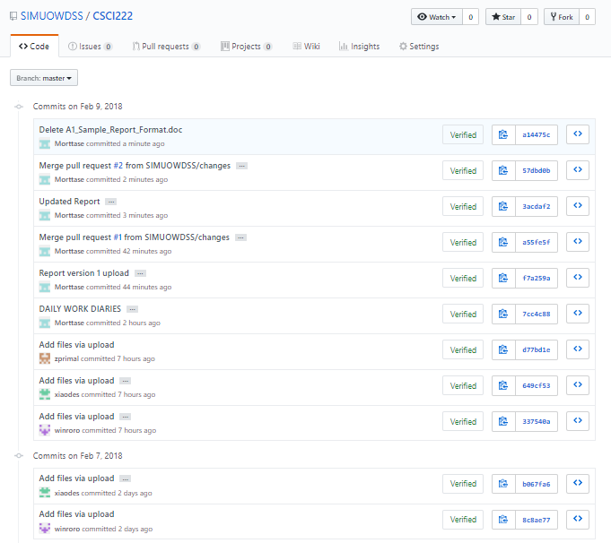

Figure C.5.1 – Screenshot that shows the history of all commits done.

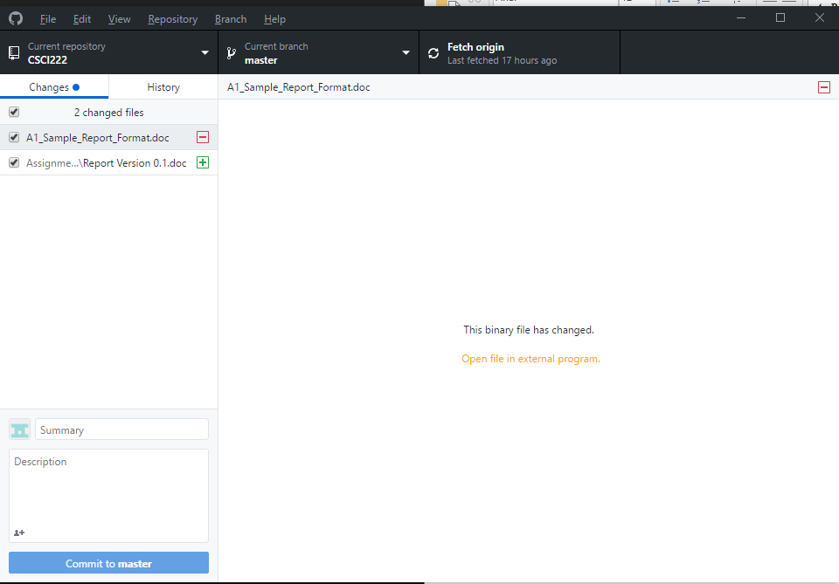

Figure C.5.2 – Screenshot from Github Desktop version showcasing the files changed.